Operator/Operand Expression Card Sets

Operator/Operand Expression sets can be printed and cut from regular printer paper, or you can write them out on construction paper, creating color-coded sets (recommended to prevent cheating and to reinforce memory cues).

Set A Question Card:

Build expressions that evaluate to the following:

7

0

2

11

8

17

18

SET A Cards:

15

8

3

%

+

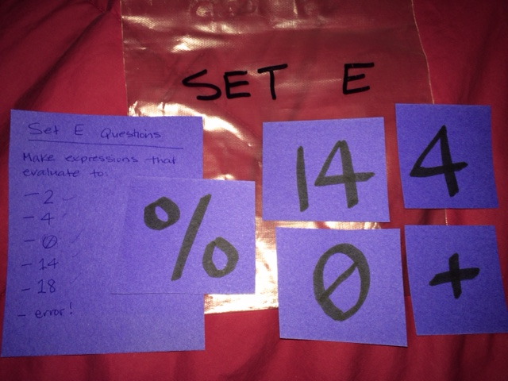

An example of the finished product.

Set B Question Card:

Build expressions that evaluate to the following:

2

36

0

1

45

4

11

Set B Cards:

9

5

4

\*

/

Set D Question Card:

Build expressions that evaluate to the following:

0

5

7

20

21

13

18

Set D Cards:

18

3

7

/

+

Set C Question Card:

Build expressions that evaluate to the following:

-1

0

9

1

2

-9

-3

Set C Cards:

10

2

3

%

-

Set E Question Card:

Build expressions that evaluate to the following:

2

4

0

14

18

error!

Set E Cards:

0

4

14

%

+